Practical 03

Aim: Perform the following:

* Altering a Table
* Dropping/Truncating/Renaming Tables

Source Code:

1. Creating Database

Code: CREATE DATABASE STUDENTS;

Output:



1. Viewing Databases

Code: SHOW DATABASES;

Output:

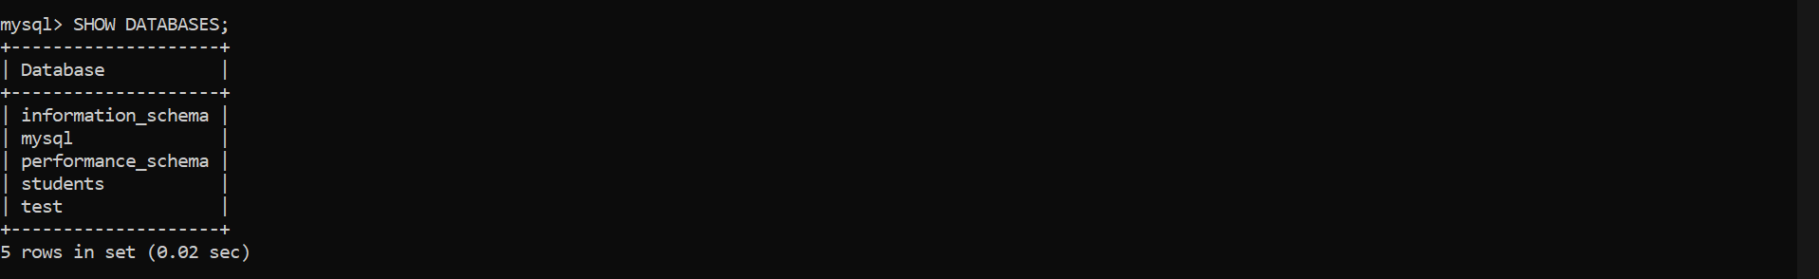

1. Creating a Table

Code: CREATE TABLE STUDENTS;

Output:



1. Viewing the Table

Code: DESC Students;

Output:

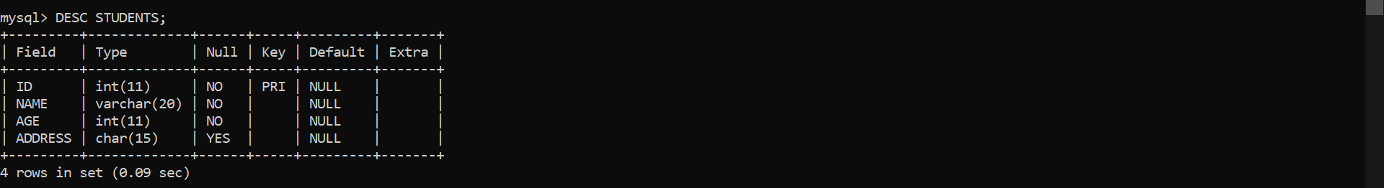

1. Inserting Records in the Table

Code: INSERT INTO STUDENTS

VALUES(1, ‘GAURANG’, 17, ‘KANDIVALI’),

(2, ‘MANOHAR’, 18, ‘MALAD’),

(3, ‘ASHMI’, 18, ‘KANDIVALI’),

(4, ‘DHANANJAY’, 18, ‘KANDIVALI’),

(5, ‘NEEL’, 17, ‘AHEMDABAD’);

Output:

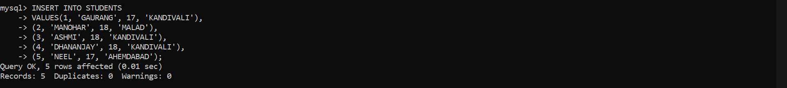

1. Viewing The Table(with constraints)

Code: SELECT \* FROM STUDENTS;

Output:

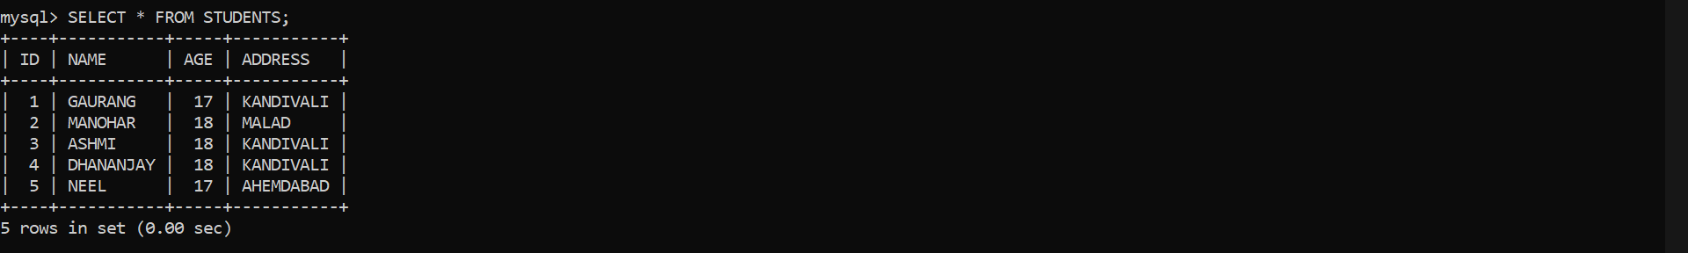

1. Altering the table

Code: ALTER TABLE STUDENTS

ADD EMAIL VARCHAR(20);

Output:



1. Viewing table after Altering

Code: SELECT \* FROM STUDENTS;

Output:

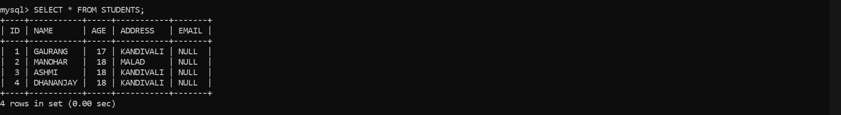

1. Altering the table(Dropping)

Code: ALTER TABLE STUDENTS

DROP COLUMN EMAIL;

Output:



1. Viewing table after altering(dropping)

Code: SELECT \* FROM STUDENTS;

Output:

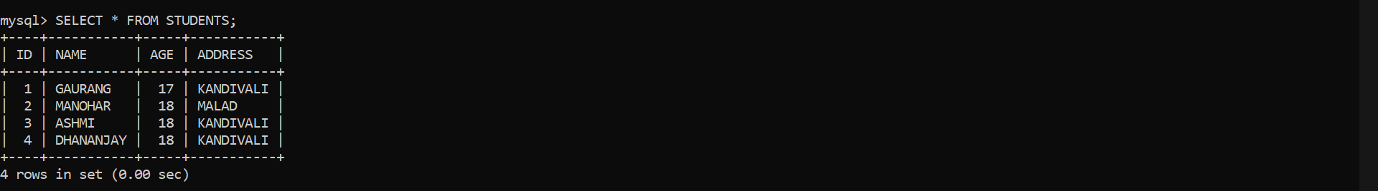

1. Altering table(renaming)

Code: ALTER TABLE STUDENTS

RENAME TO CUSTOMERS;

Output:



1. Viewing after altering(renaming)

Code: SELECT \* FROM CUSTOMERS;

Output:

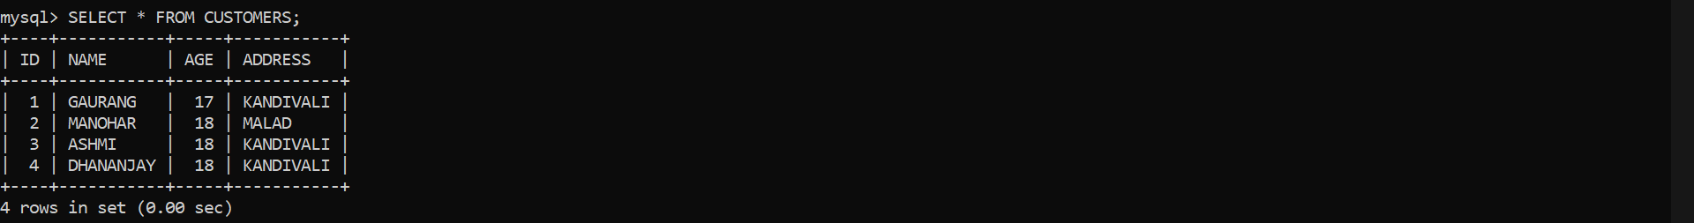

1. Truncating Table

Code: TRUNCATE TABLE CUSTOMERS;

Output:



1. Viewing after truncating table

Code: SELECT \* FROM CUSTOMERS;

Output:



Conclusion:

I have performed this practical altering the table, renaming, dropping, truncating table successfully.